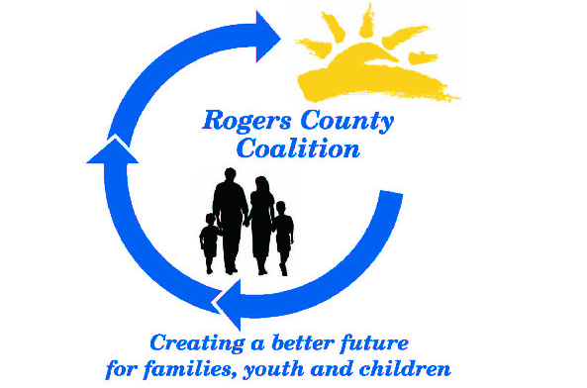

The Rogers County Coalition would like to include and/or update your information
for our 2019-20 Resource Guide.

This is a widely utilized publication that provides resource information in Rogers County. If you would like to be included in the updates, please complete the form and return by July 16 to:
Tonda Ames
Rogers County Coalition
12203 N 70th E Ave
Collinsville, OK 74021
Or Email: Tonda-ames@ouhsc.edu

Information must be returned by July 16 to be included. Forms can be mailed or emailed. Thank you.

